February 20, 2022

*Sent Via E-mail:* <<OPPOSING_COUNSEL_EMAIL>>

<<OPPOSING_COUNSEL_NAME>>

***RE:*** *<<PROVIDER_SUITNAME>> a/a/o <<INJUREDPARTY_NAME>> v. <<INSURANCECOMPANY_SUITNAME>>, Case No.* <<INDEXORAAA_NUMBER>>

***Settlement Communication: The following confidential communication is intended only for settlement purposes and as an offer of compromise only, and may not be used for any other purpose than as intended.  The following communication is privileged within the meaning and intent of Florida Statute §90.408 and other applicable law and may not be deemed as an admission against interest whether pursuant to Florida Statute §90.803(18) or otherwise.***

Dear Counselor,

The purpose of this letter is to propose early settlement of the above-referenced matter.

Our client is willing to accept the sum of $<<CLAIM_AMOUNT>> for indemnity, plus $5,500.00 for its attorney’s fees and costs in full satisfaction of this claim.

Please convey our offer to your client and get back to us at you earliest convenience.

In exchange for the payment of the foregoing funds, our client will execute a settlement agreement and/or release limited to the services rendered, and will dismiss the pending lawsuit with prejudice.

This offer is contingent upon payment of the agreed amount within thirty (30) days of the acceptance of the offer. This offer will remain open for you to accept for the next ten (10) days.

Sincerely,

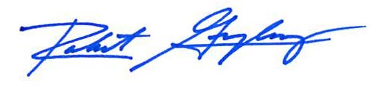

Robert F. Gonzalez, Esq.